Raven ACE
Online Examination & Certification System

Preliminary Documentation
Version 1.2.0 | June 2026

Table of Contents
1. Abstract
2. Introduction
3. Problem Definition
4. System Architecture & Technologies
5. Implementation & Dependencies
6. Achievements & Progress
7. Future Work
8. References

1. Abstract
Raven ACE Pro is a full-stack, AI-augmented web-based online examination and certification platform built with the MERN stack (MongoDB, Express.js, React, Node.js). It digitises the end-to-end lifecycle of academic and professional assessments, enabling instructors to author and publish examinations and students to take timed, proctored assessments and receive instant automated grading with per-question feedback.

Version 1.2.0 (Phase 12) introduces a fully integrated AI module powered by Google Gemini 2.5 Flash, adding seven capabilities: AI Tutor (conversational post-exam guidance), AI Question Generator (topic-prompted question authoring), AI Written Grader, AI Code Grader, AI Performance Analysis, AI Cheat Behavioral Analysis, and cross-student Plagiarism Detection. The notification system is simultaneously extended with four new AI-driven notification types and a redesigned paginated inbox.

2. Introduction

2.1 Background
The acceleration of digital learning has created an urgent need for reliable, secure, and intelligent online assessment platforms. Traditional paper-based examinations suffer from logistical constraints including physical-presence requirements, manual grading delays, and inability to scale. Existing digital solutions often lack anti-cheat mechanisms, real-time notifications, or automated certification workflows.

Recent advances in large language models provide an opportunity to close long-standing gaps: instructors spend significant time writing exam questions, students receive limited explanatory feedback, and institutions lack automated plagiarism detection or at-risk learner identification integrated natively into examination platforms.

2.2 Project Scope
Raven ACE Pro covers the full examination lifecycle across six operational domains:
- Authoring — CRUD exam management with a reusable question bank (MCQ, True/False, Written, Coding) and optional AI-generated question sets.
- Delivery — Timed, proctored, fullscreen exam-taking with continuous per-answer auto-save.
- Assessment — Automated server-side grading for objective questions; AI grading (Gemini) for written and coding questions.
- Certification — Automatic UUID-identified certificate issuance with public verification endpoint.
- Analytics — Per-exam statistics, leaderboards, CSV/PDF export, plagiarism reports, and AI performance analyses.
- AI Intelligence Layer — Tutor, question generation, grading, performance analysis, cheat analysis, and plagiarism detection via Gemini 2.5 Flash.

2.3 Context
Development followed an iterative 12-phase methodology. Phases 1–11 built core authentication, exam management, anti-cheat proctoring, certificates, leaderboards, admin panel, real-time Socket.io notifications, dark mode, and responsive layout. Phase 12 delivered the complete AI module and enhanced notifications described in this document.

3. Problem Definition

3.1 The Problem
# | Problem Area | Description
1 | Exam Integrity | Without proctoring, online exams are susceptible to cheating via tab-switching, copy-pasting, and external resources.
2 | Manual Grading Bottleneck | Grading written and coding answers manually introduces delays and cannot scale. No integrated AI grading exists in most platforms.
3 | Fragmented Toolchains | Institutions use separate tools for creation, delivery, grading, certificates, and analytics — causing data silos and friction.
4 | Certificate Forgery | Traditional certificates are easily forged. Employers have no standardised way to verify a claimed credential.
5 | Limited Student Feedback | Students receive pass/fail scores with no personalised guidance or post-exam tutoring available natively.
6 | Question Authoring Effort | Instructors spend disproportionate time writing diverse, high-quality questions with no AI assistance tool integrated in the platform.
7 | Plagiarism Detection | Comparing written answers across a student cohort requires dedicated external tools rarely integrated into examination platforms.

3.2 Significance
These challenges undermine the credibility, efficiency, and accessibility of online education. Raven ACE Pro addresses all of them within a single integrated platform, reducing institutional overhead, improving student outcomes through AI-powered personalized feedback, strengthening exam integrity, and providing a verifiable credentialing mechanism.

4. System Architecture & Technologies

4.1 High-Level Architecture
Raven ACE Pro follows a decoupled client–server architecture. The React SPA communicates with the Node.js/Express backend over REST (JWT-authenticated) and WebSocket (Socket.io, JWT handshake). The backend hosts a dedicated AI Service Layer that calls the Google Gemini REST API. All data is persisted in MongoDB via Mongoose.

┌─────────────────────────────────────────────────────────────┐
│ CLIENT (Browser) │
│ React SPA (32 pages/components) │
│ Axios (HTTP/JWT) Socket.io Client │
└──────────────┬──────────────────────────┬───────────────────┘
│ REST (HTTP) │ WebSocket
▼ ▼
┌─────────────────────────────────────────────────────────────┐
│ SERVER (Node.js / Express :5000) │
│ ┌──────────────────────────────────────────────────────┐ │
│ │ 11 Route Modules → 10 Controllers │ │
│ │ Middleware: JWT Auth │ Rate Limiter │ Multer Upload │ │
│ │ Socket.io Server (JWT handshake, user-socket map) │ │
│ └──────────────────────────────────────────────────────┘ │
│ ┌────────────── AI SERVICE LAYER ──────────────────────┐ │
│ │ geminiService.js (key rotation, retry, fallback) │ │
│ │ writtenGraderService │ codeGraderService │ │
│ │ tutorService │ questionGenService │ │
│ │ performanceService │ cheatAnalysisService │ │
│ │ plagiarismService │ similarityUtils │ │
│ └───────────────────────────────┬───────────────────────┘ │
└──────────────────┬───────────────│───────────────────────────┘
│ Mongoose ODM │ fetch() → Gemini REST API
▼ ▼
┌───────────────────────────┐ ┌──────────────────────────┐
│ MongoDB (11 collections) │ │ Google Gemini 2.5 Flash │
│ Users, Exams, Questions │ │ (external AI service) │
│ Attempts, Certificates │ └──────────────────────────┘
│ CheatLogs, Notifications │
│ AiAnalysis, ChatMessages │
│ PlagiarismReports │
└───────────────────────────┘

4.2 Use Case Diagram
The system defines four actors: Student, Instructor, Admin, and Public (unauthenticated). All authenticated roles also access shared use cases (Profile, Notifications).

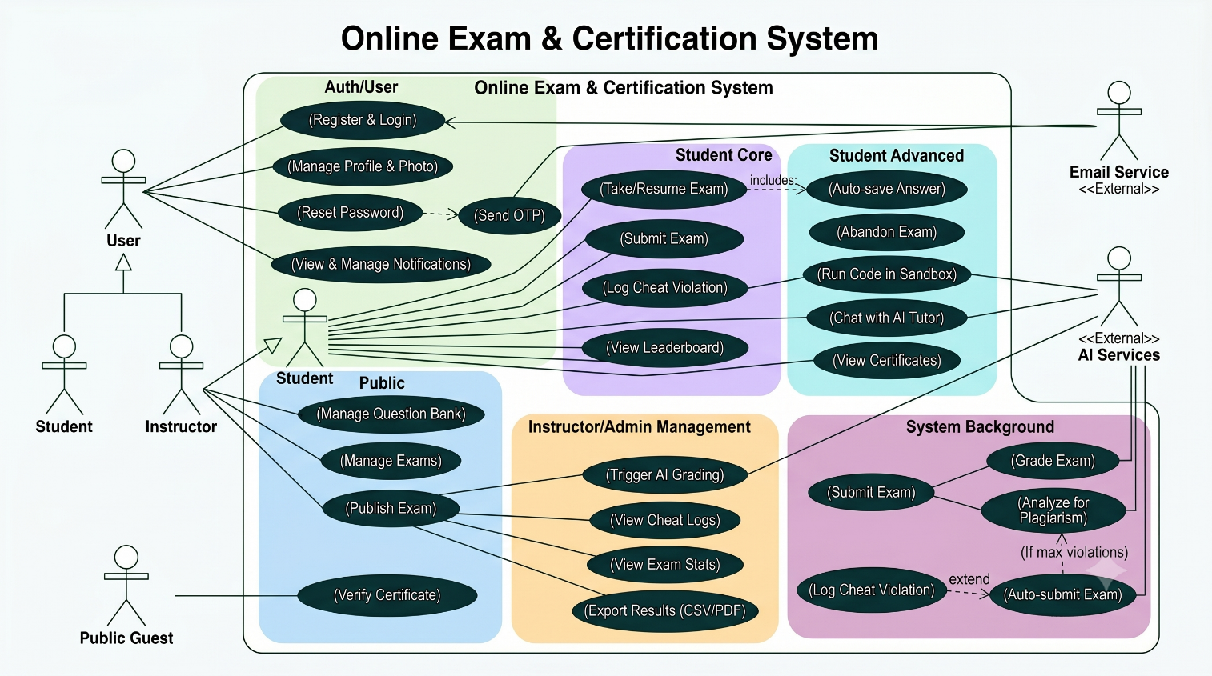

4.3 Entity-Relationship Diagram (ERD)
Raven ACE Pro uses 11 MongoDB collections. The diagram below shows every collection, its key fields, and the foreign-key relationships between them.
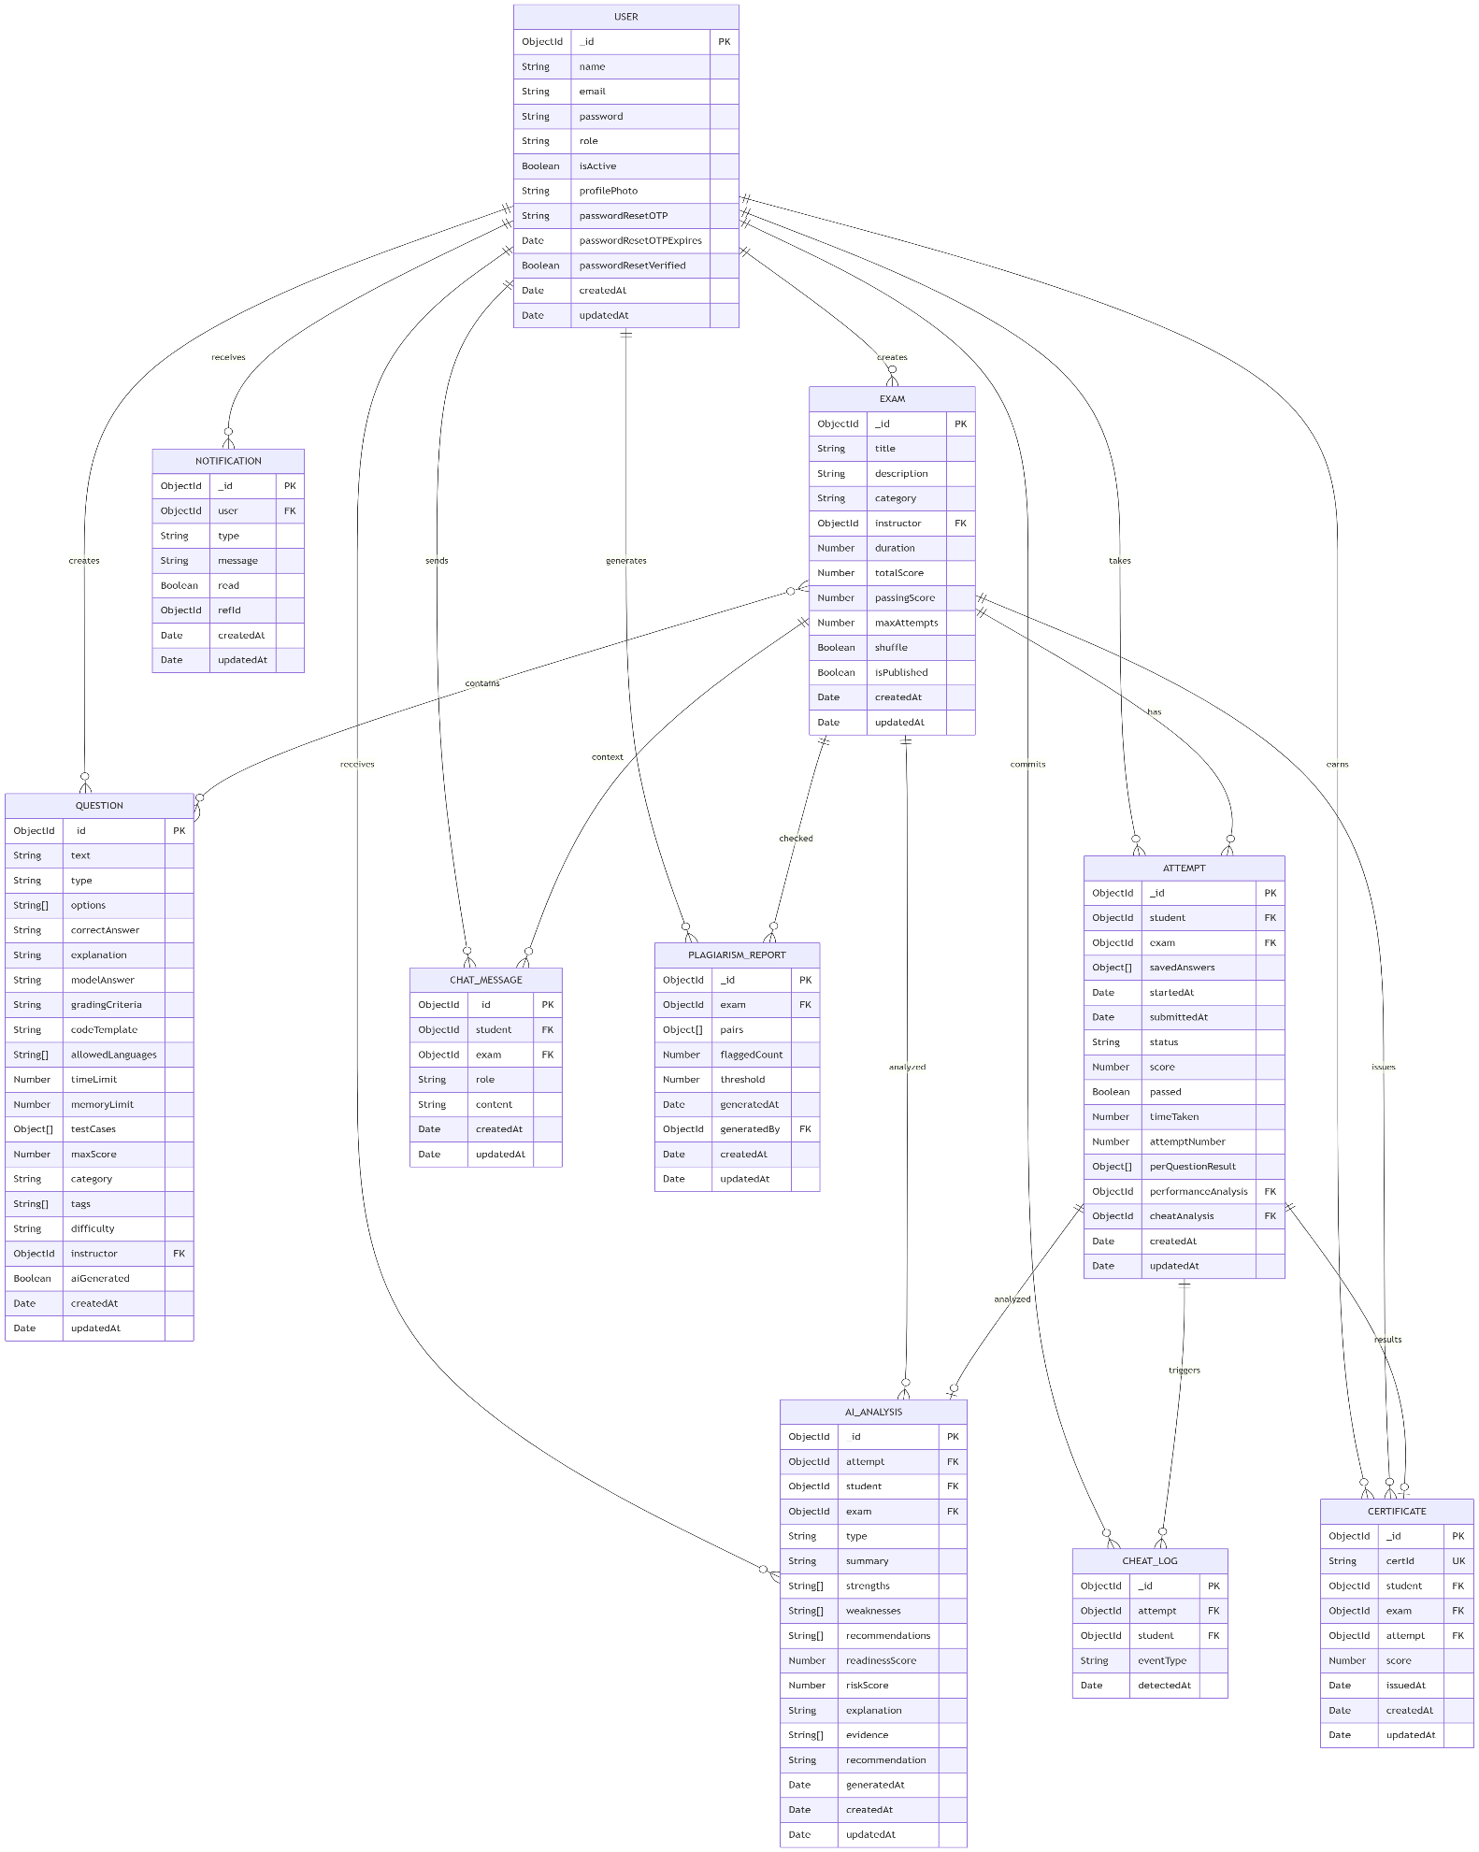

4.4 Technology Stack
Layer | Technology | Version | Purpose
Runtime | Node.js | 18+ | Server-side JS; native fetch for Gemini calls
Backend | Express.js | 4.18.2 | REST API routing & middleware pipeline
Database | MongoDB | 6+ | Document-oriented persistence (11 collections)
ODM | Mongoose | 8.0.3 | Schema modeling, validation, pre-save hooks
Auth | JWT + bcryptjs | 9.0.2 / 2.4.3 | Stateless tokens; 10-round password hashing
Real-Time | Socket.io | 4.7.2 | WebSocket server; JWT handshake; user-socket map
AI Engine | Google Gemini API | 2.5-flash | LLM grading, tutoring, generation, analysis
Email | Nodemailer | 6.9.7 | SMTP OTP delivery (Gmail / Resend)
PDF Export | PDFKit | 0.14.0 | Server-side PDF streaming (no temp files)
File Upload | Multer | 1.4.5 | Profile photo upload (JPEG/PNG/WebP, 2 MB limit)
Rate Limit | express-rate-limit | 7.1.5 | IP-based brute-force protection on auth routes
UUID | uuid | 9.0.0 | Certificate ID generation (v4)
Frontend | React | 18.2.0 | Component-based SPA with hooks
Build Tool | Vite | 5.0.0 | Fast HMR dev server & production bundler
Routing | React Router DOM | 6.20.1 | Client-side routing with role-protected routes
HTTP Client | Axios | 1.6.2 | Promise-based HTTP with JWT Bearer interceptor
Icons | React Icons | 5.6.0 | Icon components for UI
CSS | TailwindCSS (CDN) | 3.x | Utility-first styling
Design System | Material Design 3 | — | CSS variable theming (light/dark, 20+ tokens)

5. Implementation & Dependencies

5.1 Backend Architecture
The backend uses an MVC-inspired layered architecture. server.js creates a shared HTTP server for Express and Socket.io (port 5000). Eleven route modules map to ten controllers. Seven original Mongoose models are extended by four AI-specific models (AiAnalysis, ChatMessage, PlagiarismReport, plus an extended Question schema supporting written and coding types).

5.2 AI Module

5.2.1 Gemini Service (geminiService.js)
All AI capabilities route through a single geminiService.js providing: multi-key rotation across GEMINI_API_KEY / GEMINI_API_KEYS environment variables, automatic retry with exponential backoff, model fallback from gemini-2.5-flash to gemini-1.5-flash on quota exhaustion, and a generateJSON() helper that wraps prompts in JSON-only instructions and safely parses structured responses.

5.2.2 AI Tutor (tutorService.js / AiTutor.jsx)
Students open the tutor per exam after submission. The system injects the full exam context (questions, correct answers, student's attempt result) into the Gemini system prompt. Conversation history is persisted to ChatMessage (role: user | assistant) and included in each subsequent call for multi-turn coherence. Students can clear history per exam.

5.2.3 Question Generator (questionGenService.js / QuestionGenerator.jsx)
Instructors specify topic, question count, difficulty, and types. The service prompts Gemini to return a JSON array of question objects (text, type, options, correctAnswer, explanation, modelAnswer, gradingCriteria). Instructors review, select, and save individual questions to the bank. Saved questions are flagged aiGenerated: true.

5.2.4 Written & Code Grading
writtenGraderService.js grades open-ended answers against a modelAnswer and gradingCriteria, returning score, feedback, strengths, and weaknesses. codeGraderService.js evaluates code submissions against test cases (public + hidden), returning per-test pass/fail and an overall code review. Both services update the attempt's perQuestionResult array. Batch grading (grade-all-written) processes all written answers in a single attempt.

5.2.5 Performance Analysis (performanceService.js / AiPerformanceReport.jsx)
Triggered post-submission for any attempt. Builds a structured JSON summary (score, per-question correctness, time taken, cheat events) and requests a structured Gemini analysis: overall assessment, strengths, weaknesses, topic recommendations, study plan, and readiness score. Persisted to AiAnalysis (type: 'performance'); back-referenced from Attempt.performanceAnalysis.

5.2.6 Cheat Behavioral Analysis (cheatAnalysisService.js / CheatAnalysis.jsx)
Instructors trigger analysis per attempt. The service serializes all CheatLog documents (eventType, detectedAt, sequence) and prompts Gemini to produce a risk score (0–100), behavioral explanation, evidence bullets, and an instructor recommendation. Persisted to AiAnalysis (type: 'cheat'); back-referenced from Attempt.cheatAnalysis.

5.2.7 Plagiarism Detection (plagiarismService.js / PlagiarismReportPage.jsx)
Instructors trigger detection per exam. The service collects all submitted written answers per question, runs pairwise cosine similarity (similarityUtils.js) as a first pass, then sends high-similarity pairs to Gemini for an AI explanation of the linguistic overlap. Results are stored in PlagiarismReport with per-pair similarity, flagged status, both answers, and AI explanation.

5.3 Enhanced Notification System
Four new notification types extend the original four (result, certificate, new-exam, system):
- ai-performance — Delivered to the student when a performance analysis is generated for their attempt.
- plagiarism-alert — Delivered to the instructor when a plagiarism scan completes with flagged pairs above threshold.
- cheat-verdict — Delivered to the instructor when AI cheat analysis produces a high-risk verdict.
- system — Existing type; now also used for AI Tutor availability broadcasts.

The notification controller exposes: GET /api/notifications (paginated), PATCH /api/notifications/:id/read, PATCH /api/notifications/read-all, DELETE /api/notifications/:id. The sidebar notification bell shows a live unread count badge updated instantly via Socket.io without a page reload.

5.4 External Dependencies

Backend (Production)
Package | Version | Purpose
express | ^4.18.2 | REST API routing and middleware
mongoose | ^8.0.3 | MongoDB ODM, schema validation, hooks
bcryptjs | ^2.4.3 | Password hashing (10 salt rounds)
jsonwebtoken | ^9.0.2 | JWT signing and verification
cors | ^2.8.5 | Cross-Origin Resource Sharing
dotenv | ^16.3.1 | Environment variable loading
express-rate-limit | ^7.1.5 | Brute-force protection on auth routes
multer | ^1.4.5 | Multipart file upload (profile photos)
nodemailer | ^6.9.7 | SMTP email for OTP delivery
uuid | ^9.0.0 | UUID v4 for certificate identifiers
pdfkit | ^0.14.0 | Server-side PDF generation and streaming
socket.io | ^4.7.2 | WebSocket server for real-time notifications

Frontend (Production)
Package | Version | Purpose
react | ^18.2.0 | UI component library with hooks
react-dom | ^18.2.0 | React DOM renderer
react-router-dom | ^6.20.1 | Client-side routing with protected routes
axios | ^1.6.2 | HTTP client with JWT Bearer interceptor
react-icons | ^5.6.0 | Icon components
socket.io-client | ^4.7.2 | WebSocket client for real-time events

External Services
Service | Usage | Configuration
Google Gemini 2.5 Flash | AI grading, tutoring, question gen, all analysis | GEMINI_API_KEY / GEMINI_API_KEYS in .env
Gmail SMTP | Password-reset OTP email delivery | EMAIL_USER / EMAIL_PASS in .env
MongoDB | Primary data persistence (11 collections) | MONGO_URI in .env (local or Atlas)

6. Achievements & Progress

6.1 Phases
Phase | Feature Area
1 | Authentication (Register, Login, OTP Password Reset, JWT)
2 | Exam & Question Management (CRUD, Question Bank, MCQ + TF)
3 | Exam Taking (Countdown Timer, Per-Answer Auto-Save, Grading)
4 | Anti-Cheat Proctoring (5-type client + server tandem, auto-submit)
5 | Result Review (per-question breakdown, correct answers, explanations)
6 | Certificates (auto-issue on pass, UUID, public verify endpoint)
7 | Leaderboards & Per-Exam Statistics (aggregation, difficulty)
8 | Admin Panel (user CRUD, role management, platform statistics)
9 | Instructor Attempt Detail View, CSV Export, PDF Export
10 | Real-Time Notifications (Socket.io JWT, user-socket map, inbox)
11 | Dark Mode (CSS variable theming) & Responsive Mobile Layout
12 | AI Module (Tutor, Generator, Graders, Analyses, Plagiarism) + Enhanced Notifications

6.2 AI Features
- AI Tutor — Context-aware multi-turn conversational guidance per exam, with persistent ChatMessage history.
- AI Question Generator — Topic-prompted JSON generation of MCQ, True/False, and Written questions with instructor review and selective save.
- AI Written Grader — Per-question and batch grading against modelAnswer and gradingCriteria with score, feedback, strengths, weaknesses.
- AI Code Grader — Code submission evaluation against public/hidden test cases with per-test pass/fail results and code review feedback.
- AI Performance Analysis — Structured per-attempt report: overall assessment, strengths, weaknesses, study plan, readiness score.
- AI Cheat Behavioral Analysis — LLM analysis of CheatLog sequences producing a risk score (0–100), evidence bullets, and instructor recommendation.
- Plagiarism Detection — Pairwise cosine similarity pre-filter + Gemini AI explanation for flagged pairs, with per-pair similarity scores.

- .

6.4 Testing
A 70+ request Postman collection with auto-chained variables covers all endpoints including the new AI routes. AI endpoints are tested for valid inputs, missing context (graceful errors), and Gemini API unavailability (service degradation fallbacks). Manual end-to-end testing across all three roles validates the complete AI workflow from question generation through performance report delivery.

7. Future Work

7.1 Future Features
- Exam Scheduling — Set exam availability windows with automatic publish/unpublish on schedule.
- Student Groups / Cohorts — Create student groups and assign exams to specific cohorts rather than all students.
- Advanced Analytics Dashboard — Interactive charts (pass rate trends, score distributions, time-of-day analysis) via a charting library.
- Email Notifications — Send email alerts for exam availability, result ready, and AI report completion in addition to in-app notifications.
- Question Import/Export — Import questions from CSV/JSON and export the question bank for external reuse.
- AI Adaptive Examinations — Dynamically adjust question difficulty mid-exam based on real-time Gemini scoring feedback.
- Comprehensive Audit Logging — Timestamped audit trails for all administrative actions.

7.2 Technical Improvements
- Automated Testing Suite — Unit tests (Jest/Vitest) and integration tests for backend controllers and AI service layer.
- Production Security Hardening — helmet.js HTTP headers, CSRF protection, input sanitization, restrict Socket.io CORS from wildcard to specific origins.
- Performance Optimization — Database indexes on high-frequency fields, pagination on all list endpoints, Redis caching for leaderboard and statistics.
- Deployment Preparation — Dockerize frontend and backend, CI/CD pipeline, MongoDB Atlas with replica sets.
- Accessibility (a11y) — WCAG 2.1 compliance: ARIA labels, keyboard navigation, screen reader support.
- AI Cost Management — Token-budget controls and response caching to manage Gemini API usage costs at scale.

8. References

8.1 Technologies & Documentation
1. Node.js Foundation. (2024). Node.js Documentation. https://nodejs.org/docs/latest/api/
2. Express.js. (2024). Express — Node.js Web Application Framework. https://expressjs.com/
3. MongoDB, Inc. (2024). MongoDB Manual. https://www.mongodb.com/docs/manual/
4. Automattic. (2024). Mongoose ODM v8.x Documentation. https://mongoosejs.com/docs/guide.html
5. Auth0. (2024). JSON Web Tokens — Introduction. https://jwt.io/introduction
6. Socket.io. (2024). Socket.IO Documentation. https://socket.io/docs/v4/
7. Meta Platforms, Inc. (2024). React Documentation. https://react.dev/
8. Vite. (2024). Vite — Next Generation Frontend Tooling. https://vitejs.dev/
9. Remix Software, Inc. (2024). React Router v6 Documentation. https://reactrouter.com/
10. TailwindCSS. (2024). Tailwind CSS Documentation. https://tailwindcss.com/docs
11. Google. (2024). Material Design 3 — Design System. https://m3.material.io/
12. Google. (2025). Gemini API Documentation — REST & SDKs. https://ai.google.dev/api
13. PDFKit. (2024). PDFKit — A JavaScript PDF Generation Library for Node. http://pdfkit.org/
14. Nodemailer. (2024). Nodemailer — Send Emails from Node.js. https://nodemailer.com/about/

8.2 Security References
15. OWASP Foundation. (2024). OWASP Authentication Cheat Sheet. https://cheatsheetseries.owasp.org/cheatsheets/Authentication_Cheat_Sheet.html
16. OWASP Foundation. (2024). OWASP Top 10 Web Application Security Risks. https://owasp.org/www-project-top-ten/
17. Auth0. (2024). Token Best Practices. https://auth0.com/docs/secure/tokens/token-best-practices

8.3 Design & UX References
18. Nielsen, J. (1994). 10 Usability Heuristics for User Interface Design. Nielsen Norman Group. https://www.nngroup.com/articles/ten-usability-heuristics/
19. Google. (2024). Material Symbols and Icons. https://fonts.google.com/icons

8.4 Tools
20. Postman, Inc. (2024). Postman API Platform. https://www.postman.com/

